Terraform Task -04

- Execute the script shown in the video.
Steps Performed:
Step 1: Initialize Terraform
- Navigated to project directory Terraform basic
- Executed:
- terraform init
- Terraform initialized successfully
- Providers reused from .terraform.lock.hcl:
  - hashicorp/local v2.6.1
  - hashicorp/random v3.8.0
Initialization completed without errors
Step 2: Create Local File Resource
- Created main.tf with:
- resource "local_file" "cars" {
- filename = "Honda.txt"
- content = "I love cars"
- }
- Ran:
- terraform apply
- File Honda.txt created successfully with content:I love cars
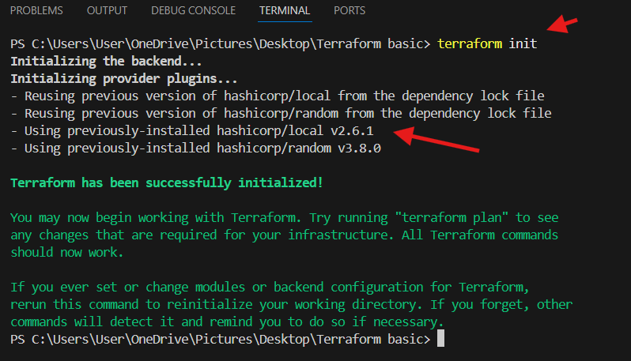
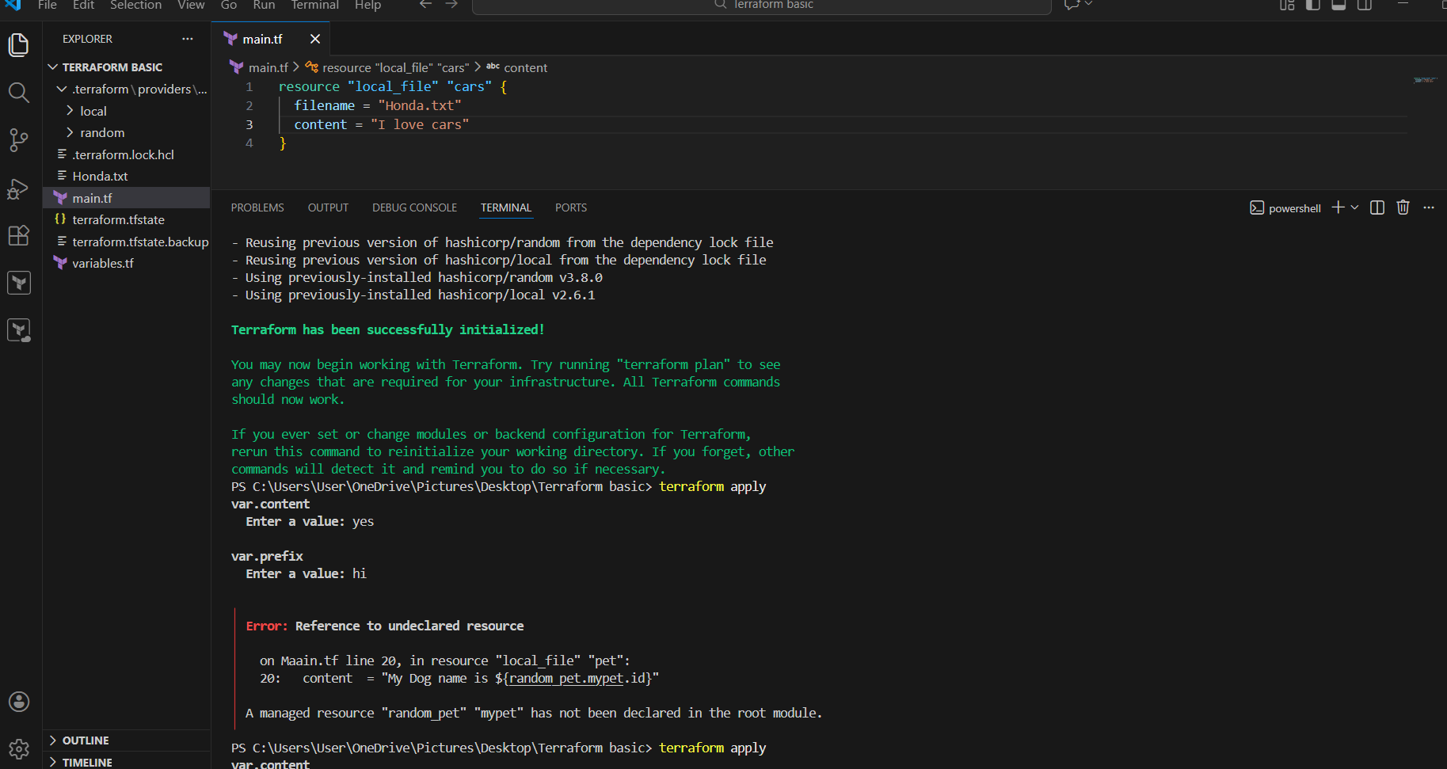
Step 3: Use Variables with terraform apply
- Terraform prompted for variable values:
  - var.content
  - var.prefix
- Entered values during apply
- Encountered error:
- Error: Reference to undeclared resource
- random_pet.mypet not declared
Error due to missing random_pet resource

Step 4: Fix Error by Declaring random_pet
- Added:
- resource "random_pet" "petname" {
- length = 1
- prefix = "MR"
- }
- Re-ran:
- terraform apply
- Terraform planned:
  - Create new local file
  - Destroy old random_pet resource
- Apply completed successfully
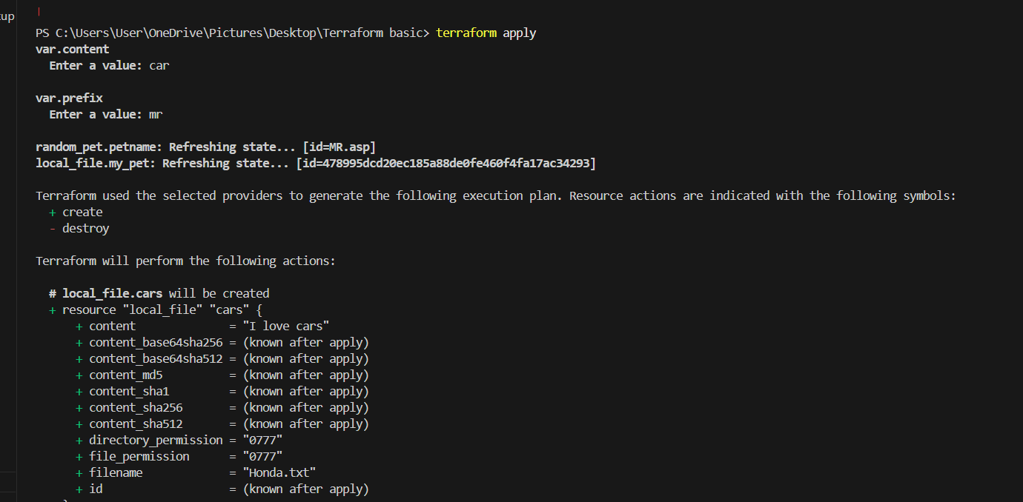
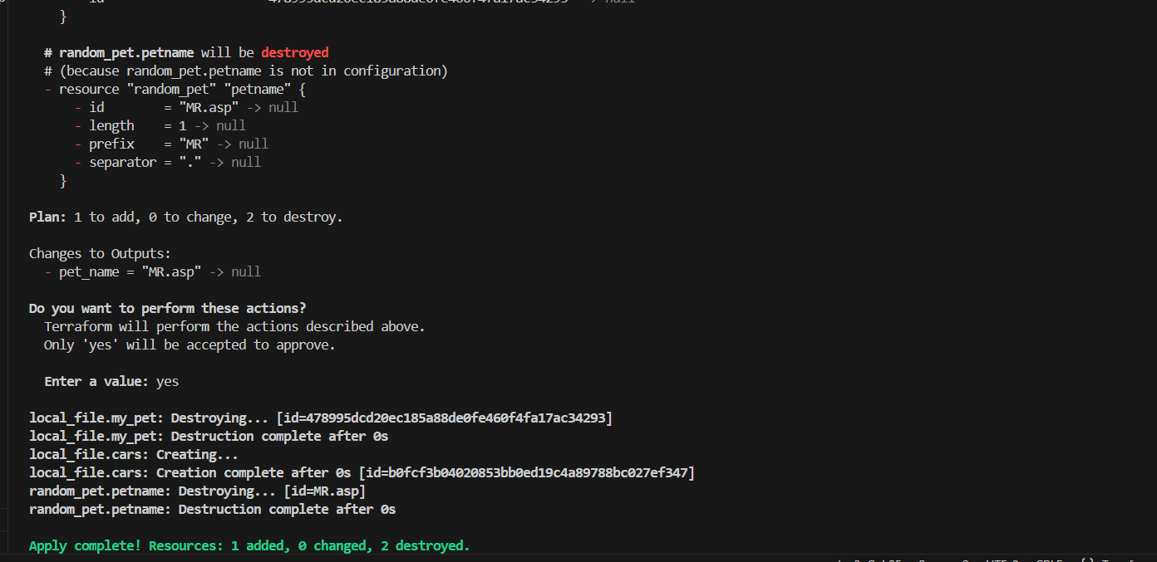
Step 5: Observe Terraform State Changes
- Terraform destroyed:
  - Old random_pet.petname
- Created:
  - New local_file.cars
- State updated correctly
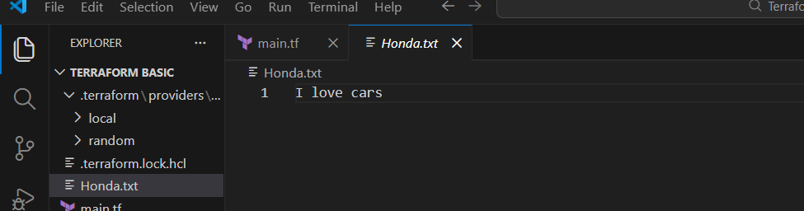
Step 6: Use Data Source (local_file)
- Added data source:
- data "local_file" "TATA" {
- filename = "TATA.txt"
- }
- Reused content in resource:
- content = data.local_file.TATA.content
- Demonstrated reading existing file content using data sources
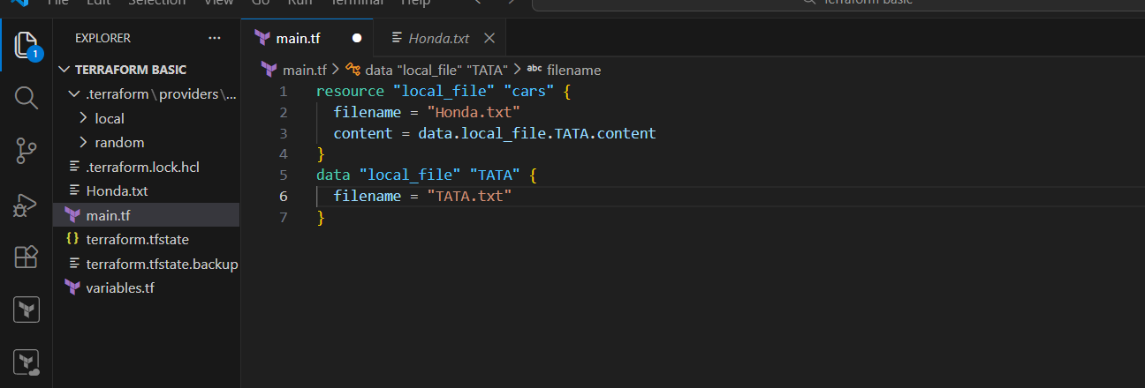
Step 7: Use count Meta-Argument
- Defined variable:
- variable "filename" {
- default = ["pets.txt", "cats.txt", "dogs.txt"]
- }
- Used count:
- resource "local_file" "my-pet" {
- filename = var.filename[count.index]
- content = "I love cats"
- count = 3
- }
- Terraform created multiple files automatically
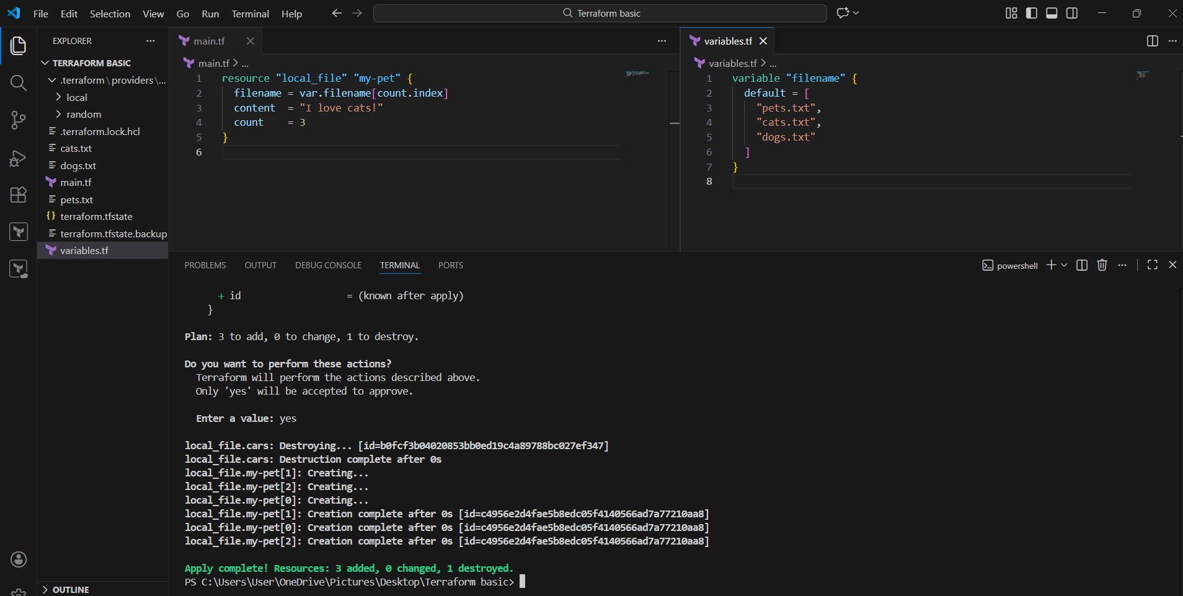
Step 8: Use for_each Meta-Argument
- Replaced count with for_each:
- resource "local_file" "pet" {
- filename = each.value
- content = "I love cats"
- for_each = toset(var.filename)
- }
- Terraform destroyed old count resources
- Created new files using for_each
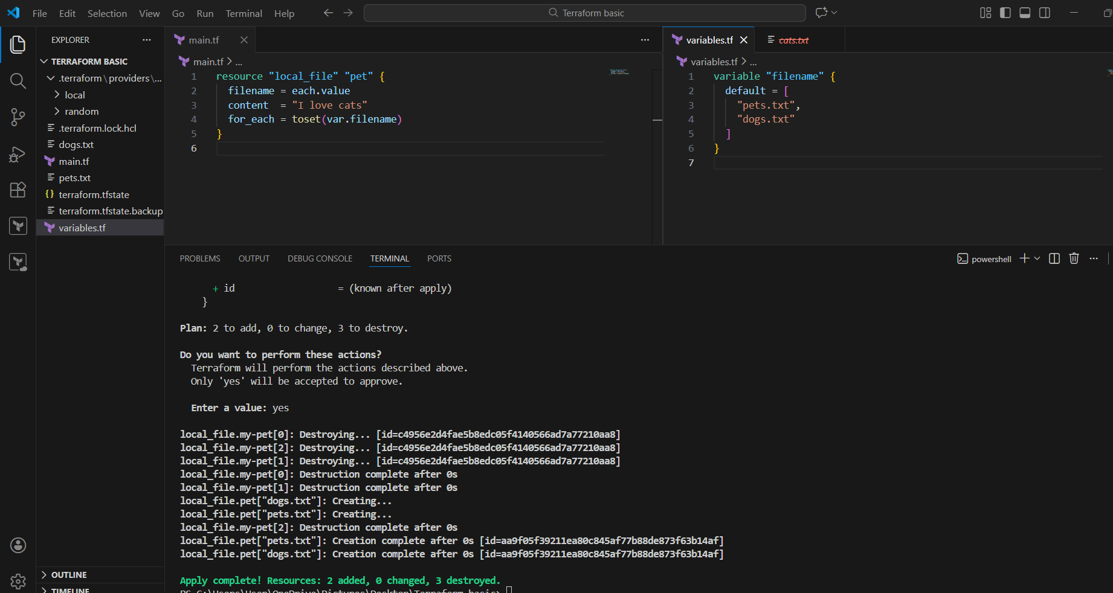
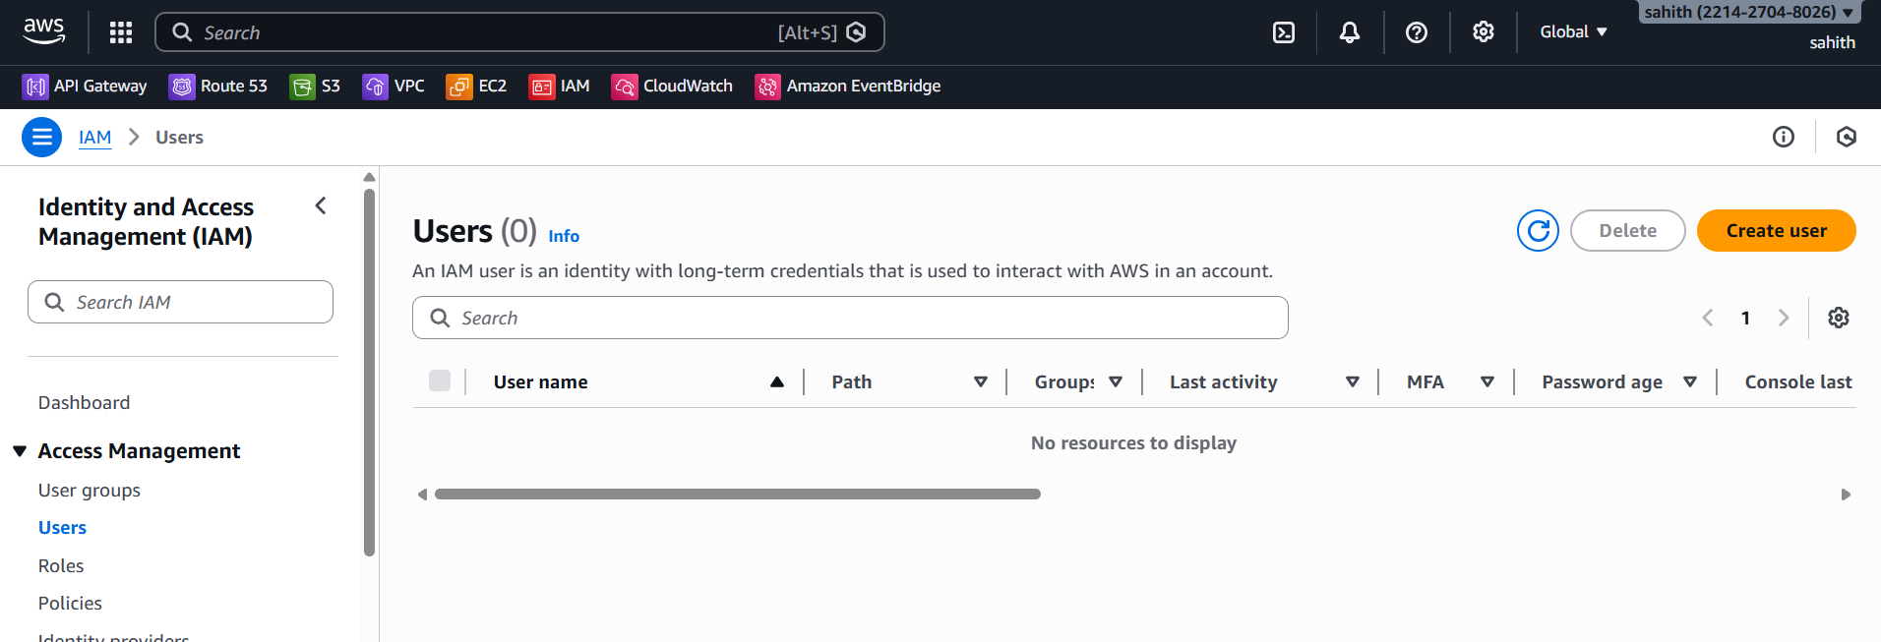
Step 9: AWS IAM User Creation Attempt
- Created IAM user resource:
- resource "aws_iam_user" "Admin-user" {
- name = "Harsha"
- tags = {
- description = "Team Lead"
- }
- }
- Ran:
- terraform apply
- Encountered error:
- Invalid provider configuration
No valid AWS credentials found
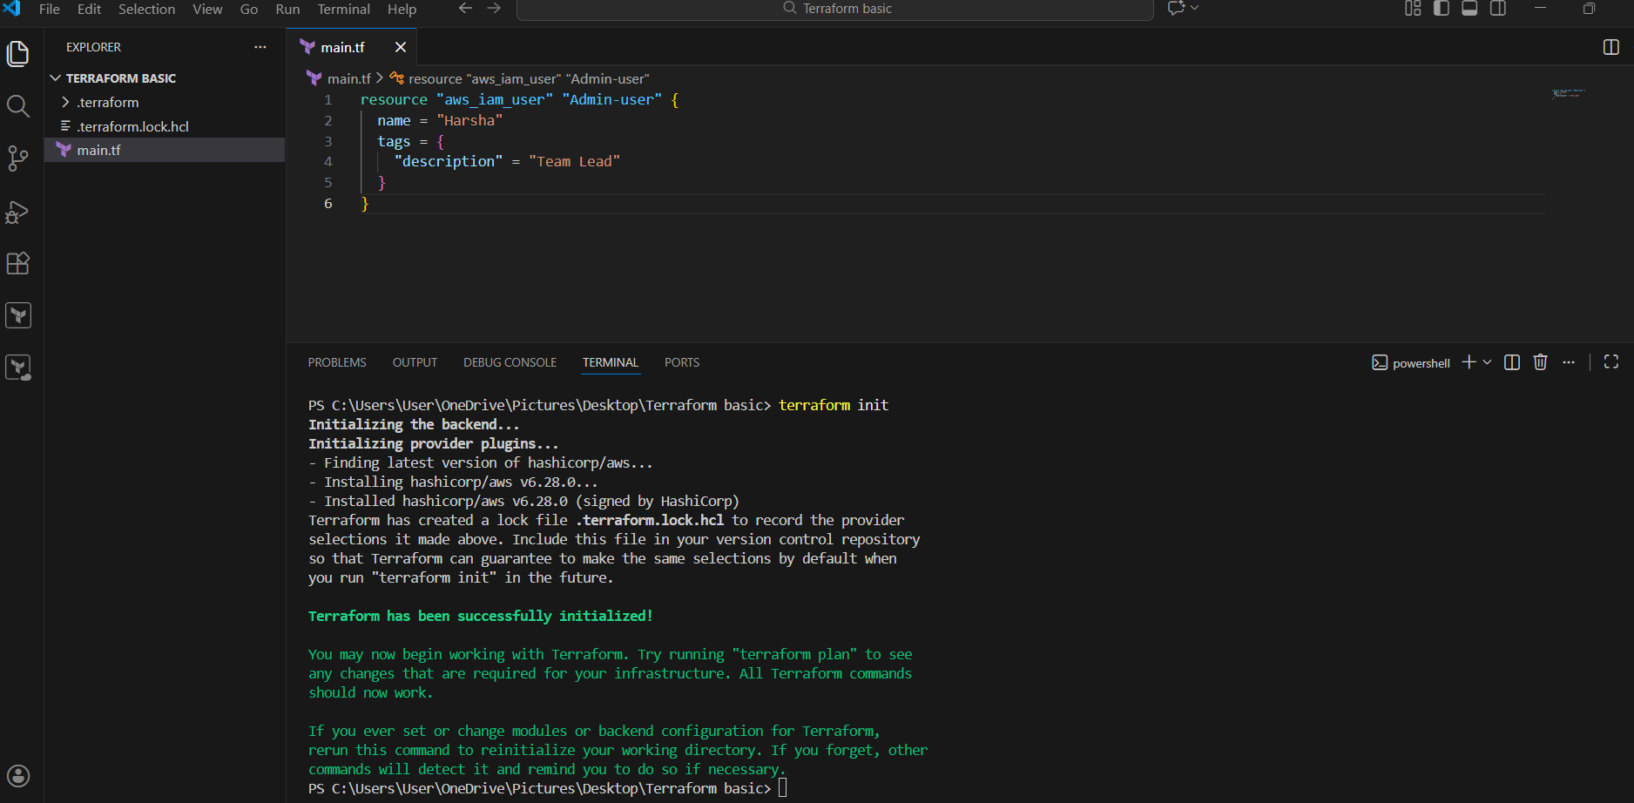
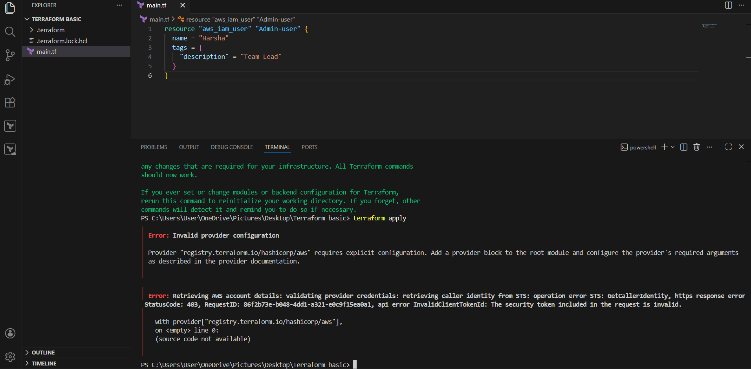
Step 10: Create AWS Access Keys
- Logged into AWS Console
- Navigated to:
- IAM → Security Credentials → Create Access Key
- Generated:
  - Access Key ID
  - Secret Access Key
- Downloaded credentials securely
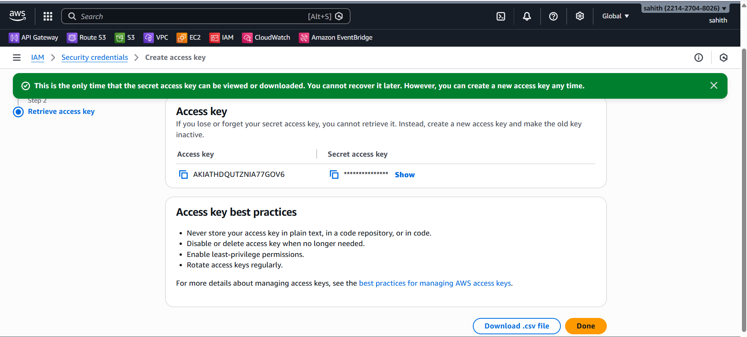
Step 11: Configure AWS Credentials
- Configured credentials locally (environment / AWS CLI)
- Re-ran Terraform after provider configuration
- AWS authentication validated successfully
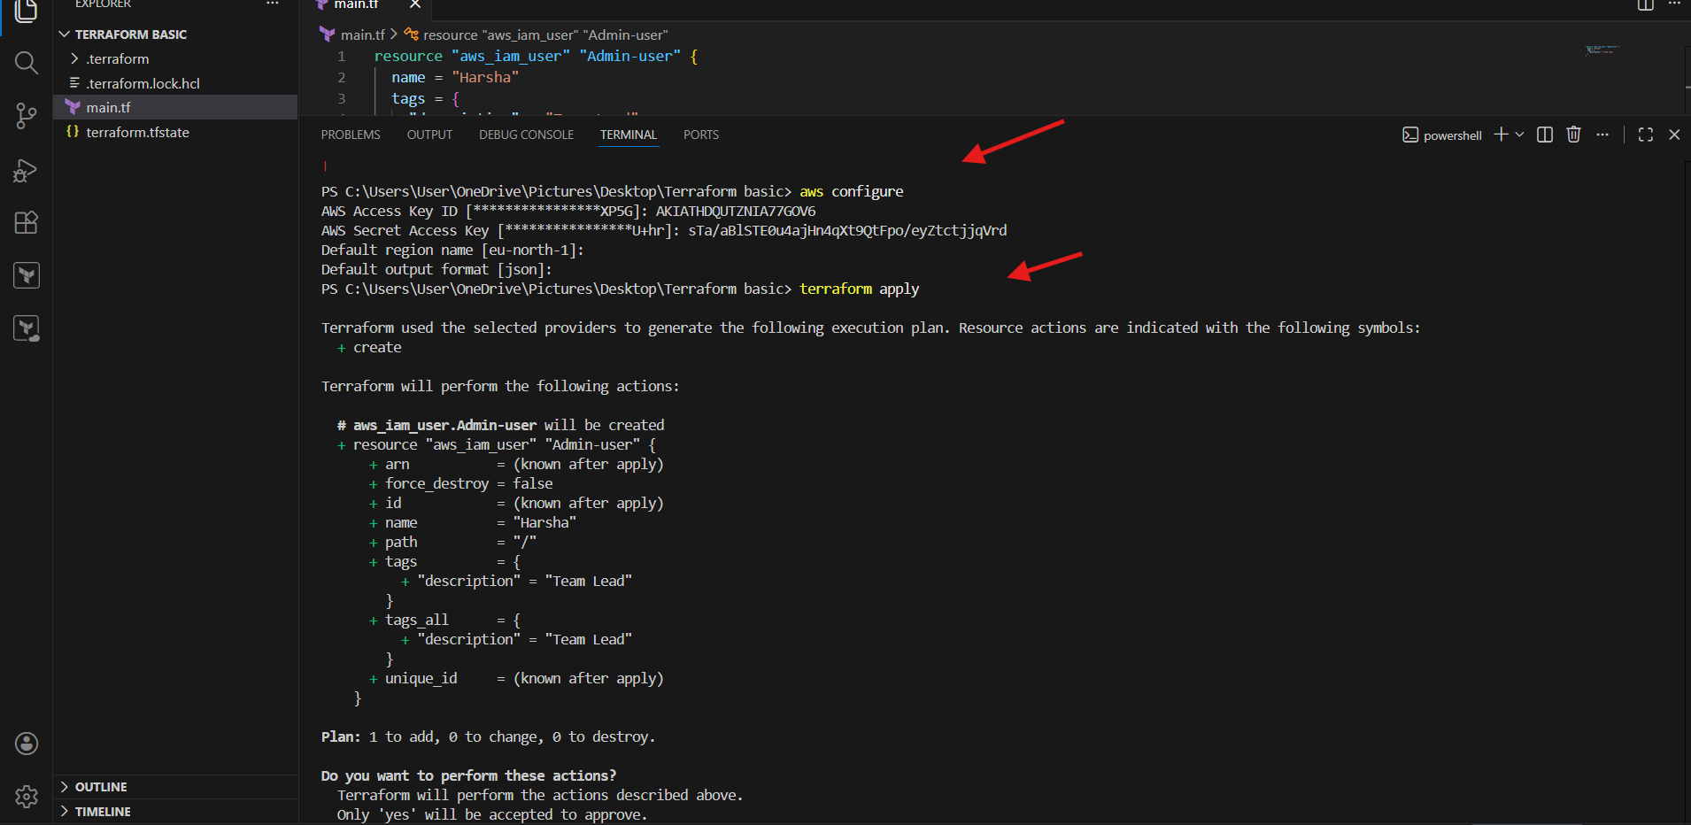
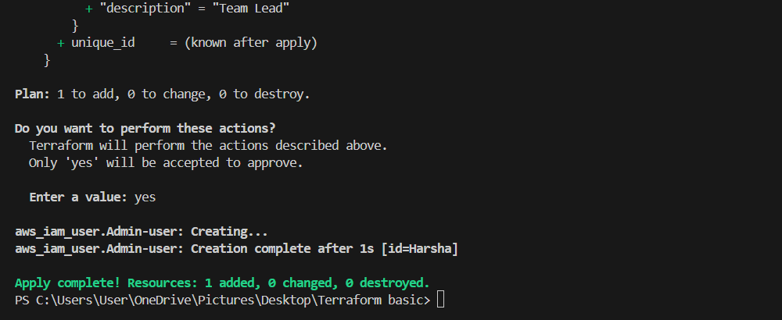
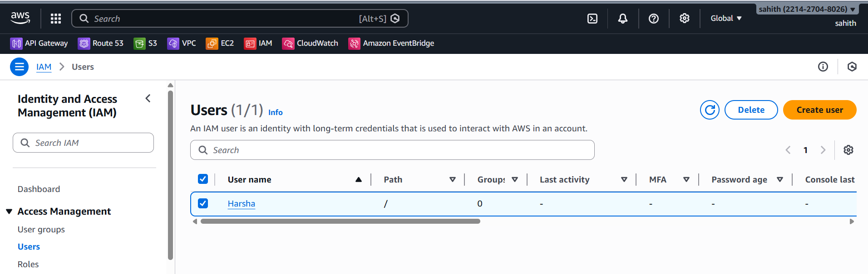
Step 11: Create IAM User Using Terraform Script
Used the following Terraform script to create an IAM user:
resource "aws_iam_user" "admin_user" {
name = "Harsha"

tags = {
description = "Team Lead"
}
}
This script defines an IAM user named Harsha with a descriptive tag indicating the user’s role.
Step 12: Create IAM Policy Using Terraform Script
Used the following Terraform script to create an IAM policy:
resource "aws_iam_policy" "admin_policy" {
name = "Harsha-Admin-Policy"
description = "Full admin access policy"

policy = jsonencode({
Version = "2012-10-17"
Statement = [
{
Sid = "AdminAccess"
Effect = "Allow"
Action = "*"
Resource = "*"
}
]
})
}
This policy grants full administrative permissions by allowing all actions on all AWS resources.
Step 13: Attach IAM Policy to IAM User
Used the following Terraform script to attach the policy to the IAM user:
resource "aws_iam_user_policy_attachment" "harsha_admin_access" {
user = aws_iam_user.admin_user.name
policy_arn = aws_iam_policy.admin_policy.arn
}
This step ensures the Harsha-Admin-Policy is directly attached to the IAM user Harsha.
Step 14: Apply Terraform Configuration
Executed the following command in the terminal:
terraform apply
Reviewed the execution plan showing the creation of the IAM user, IAM policy, and policy attachment.
Approved the execution by typing yes when prompted.
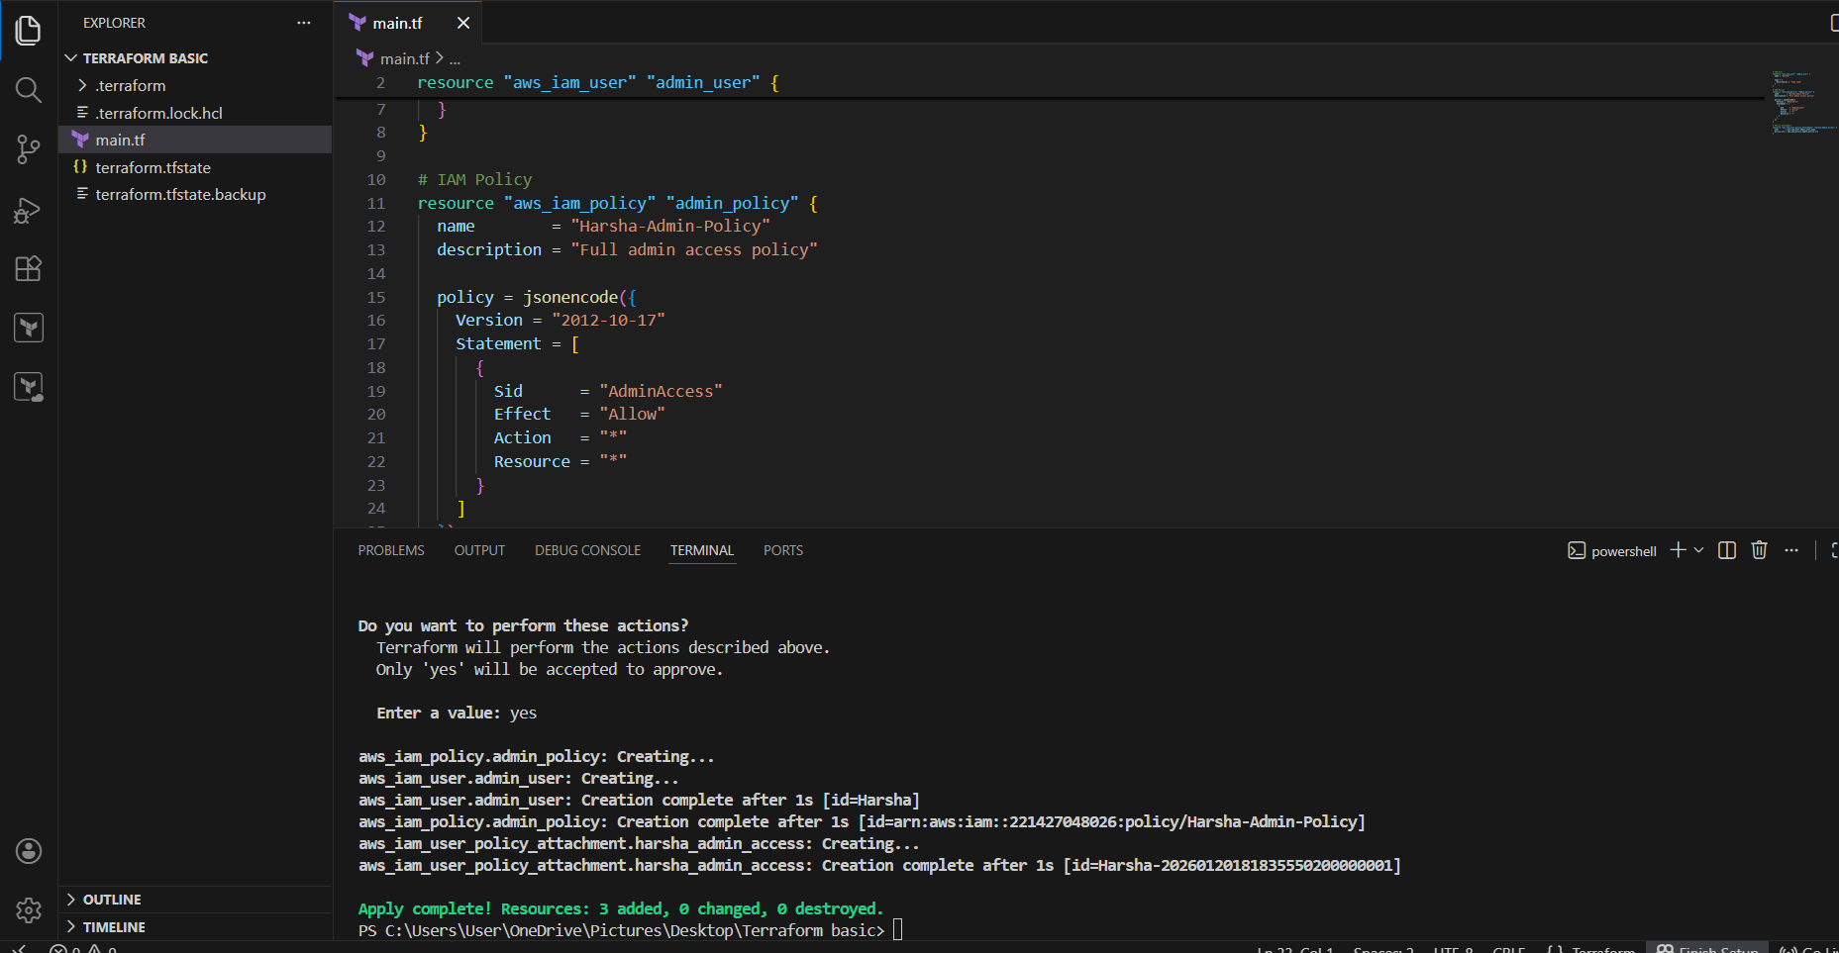
Step 15: Verify Resource Creation
Observed Terraform output confirming:
- IAM user creation
- IAM policy creation
- Successful policy attachment
Terraform displayed a successful completion message with no errors.
Step 16: Verify IAM User and Policy in AWS Console
Logged in to the AWS Management Console.
Navigated to:
IAM → Users → Harsha
Verified that:
- The IAM user Harsha exists
- The Harsha-Admin-Policy is attached
- Policy type is Customer managed
- Policy is attached directly to the user
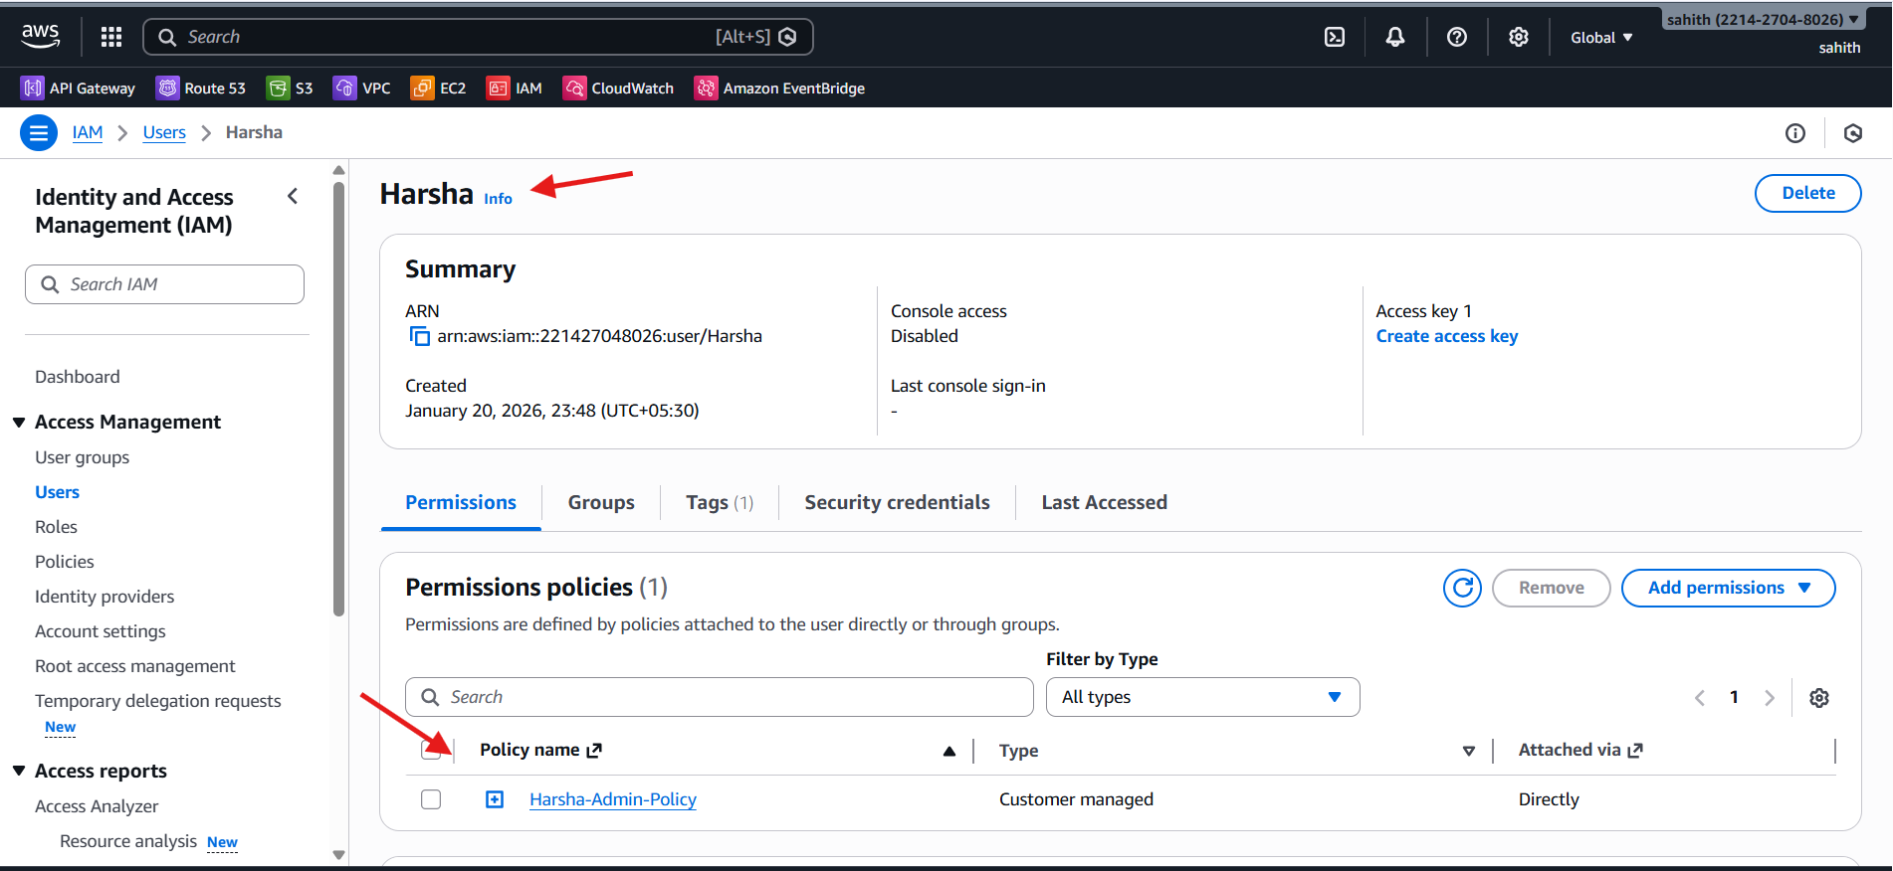

3. Integrate Terraform in Jenkins using the Terraform plugin.
Steps performed:
Step 1: Install Terraform Plugin in Jenkins
Opened the Jenkins dashboard in a web browser.
Navigated to:
Manage Jenkins → Plugins → Installed plugins
Searched for Terraform in the plugin search bar.
Verified that the Terraform Plugin was installed and enabled successfully.
Step 2: Configure Terraform Tool in Jenkins
From the Jenkins dashboard, navigated to:
Manage Jenkins → Tools
Scrolled down to the Terraform installations section.
Clicked on Add Terraform to configure a new Terraform installation.
Step 3: Set Terraform Installation Details
Provided the name for the Terraform installation as Terraform.
Enabled the option Install automatically.
Selected the installer option Install from bintray.com.
Chose the Terraform version as:
Terraform 5.12.3 linux (amd64)
Ensured the correct version was selected for the Jenkins environment.
Step 4: Save Jenkins Tool Configuration
Clicked on Save to apply the Terraform tool configuration.
Confirmed that Terraform was successfully added under Jenkins global tools.
This completed the Terraform plugin installation and configuration in Jenkins.
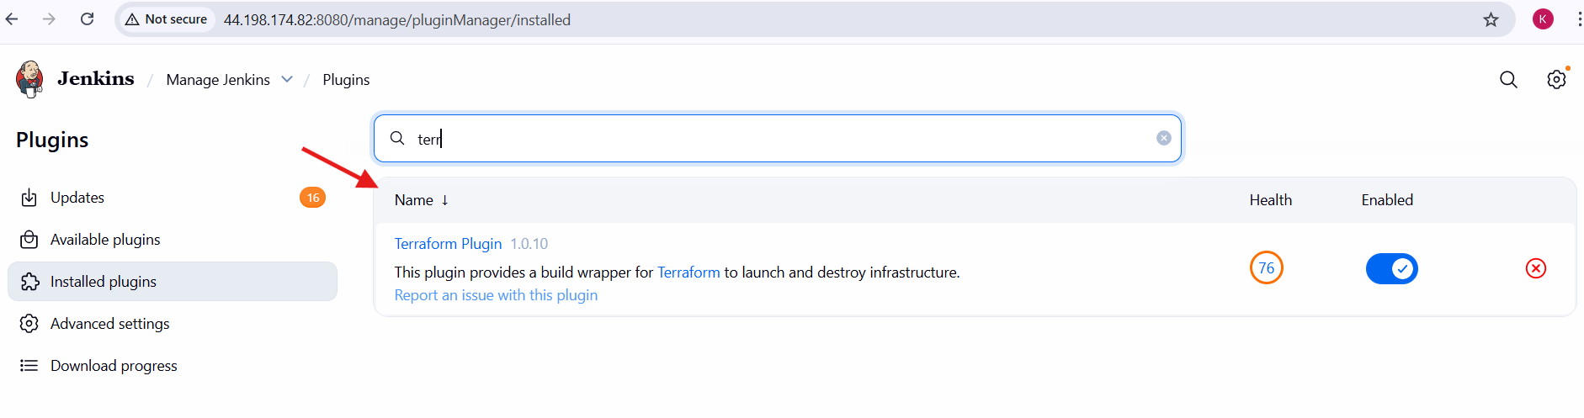
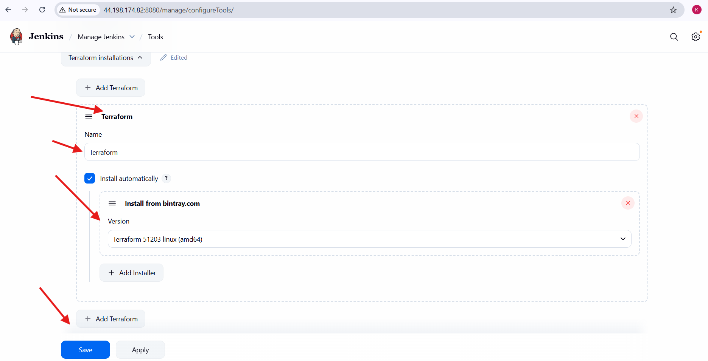

4. Create a CI/CD pipeline for a Nodejs Application: https://github.com/betawins/Trading-UI.git

Task Title
Create a CI/CD Pipeline for a NodeJS Application using Jenkins
Objective
To design and implement a CI/CD pipeline using Jenkins for a NodeJS application by integrating a GitHub repository, installing required tools, and automating the build and test processes using a Jenkins pipeline.
Prerequisites
- Jenkins server installed and running
- NodeJS plugin installed in Jenkins
- NodeJS configured in Jenkins Global Tool Configuration
- Git installed on the Jenkins server
- GitHub account with access to the NodeJS application repository
- Public GitHub repository containing a Jenkinsfile
- Basic knowledge of Jenkins pipelines and NodeJS

Steps Performed:
Step 1: Install NodeJS Plugin in Jenkins
Opened the Jenkins dashboard in a web browser.
Navigated to:
Manage Jenkins → Plugins → Available plugins
Searched for NodeJS in the plugin search box.
Selected the NodeJS Plugin.
Clicked on Install to install the plugin.
Waited for the installation to complete successfully.
Step 2: Configure NodeJS Tool in Jenkins
From the Jenkins dashboard, navigated to:
Manage Jenkins → Tools
Scrolled to the NodeJS installations section.
Clicked on Add NodeJS.
Step 3: Set NodeJS Installation Details
Entered the NodeJS installation name as:
Nodejs
Enabled the option Install automatically.
Selected Install from nodejs.org.
Chose the NodeJS version:
NodeJS 16.20.2
Clicked on Save to apply the configuration.
Step 4: Verify GitHub Repository
Opened the GitHub repository in a browser:
https://github.com/krishnav7090/Trading-UI
Verified that the repository contains:
- Source code
- package.json
- package-lock.json
- Jenkinsfile
Confirmed that the repository is public and accessible.
Step 5: Create a New Jenkins Pipeline Job
Opened the Jenkins dashboard.
Clicked on New Item.
Entered the job name as:
Terraform-Nodejs
Selected Pipeline as the project type.
Clicked on OK.
Step 6: Configure Pipeline Script from SCM
In the job configuration page, navigated to the Pipeline section.
Selected Pipeline script from SCM.
Chose Git as the SCM.
Step 7: Configure Git Repository Details
Entered the repository URL:
https://github.com/krishnav7090/Trading-UI.git
Left credentials as none (public repository).
Set the branch specifier as:
*/master
Step 8: Configure Jenkinsfile Path
Verified that the Script Path is set to:
Jenkinsfile
Enabled Lightweight checkout.
Clicked on Save to save the pipeline configuration.
Step 9: Run the Jenkins Pipeline
From the Jenkins job dashboard, clicked on Build Now.
Observed Jenkins performing the following stages:
- Checkout source code from GitHub
- Install NodeJS tool
- Verify Node and npm versions
- Install dependencies using npm install
- Build the application using npm run build
- Execute tests using npm test
Step 10: Verify Pipeline Execution
Opened the build details page.
Verified that the pipeline completed successfully with a green check mark.
Checked the console output to confirm:
- No errors occurred
- All stages executed successfully
- Build duration and Git commit details were displayed
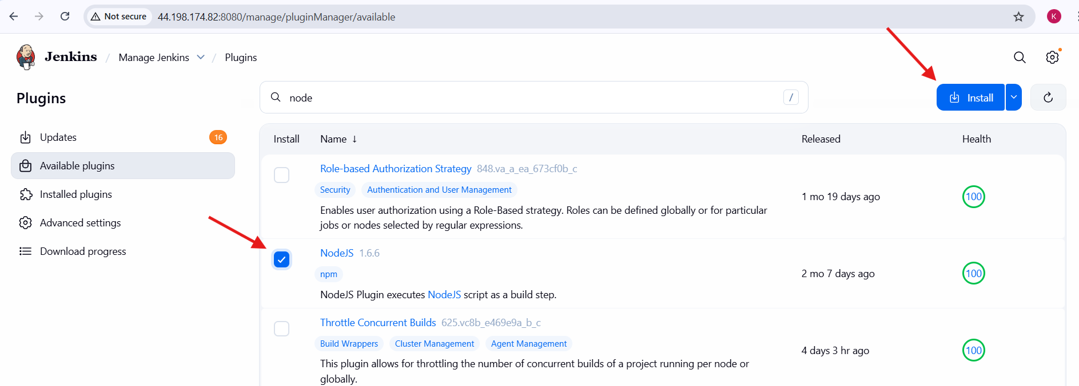
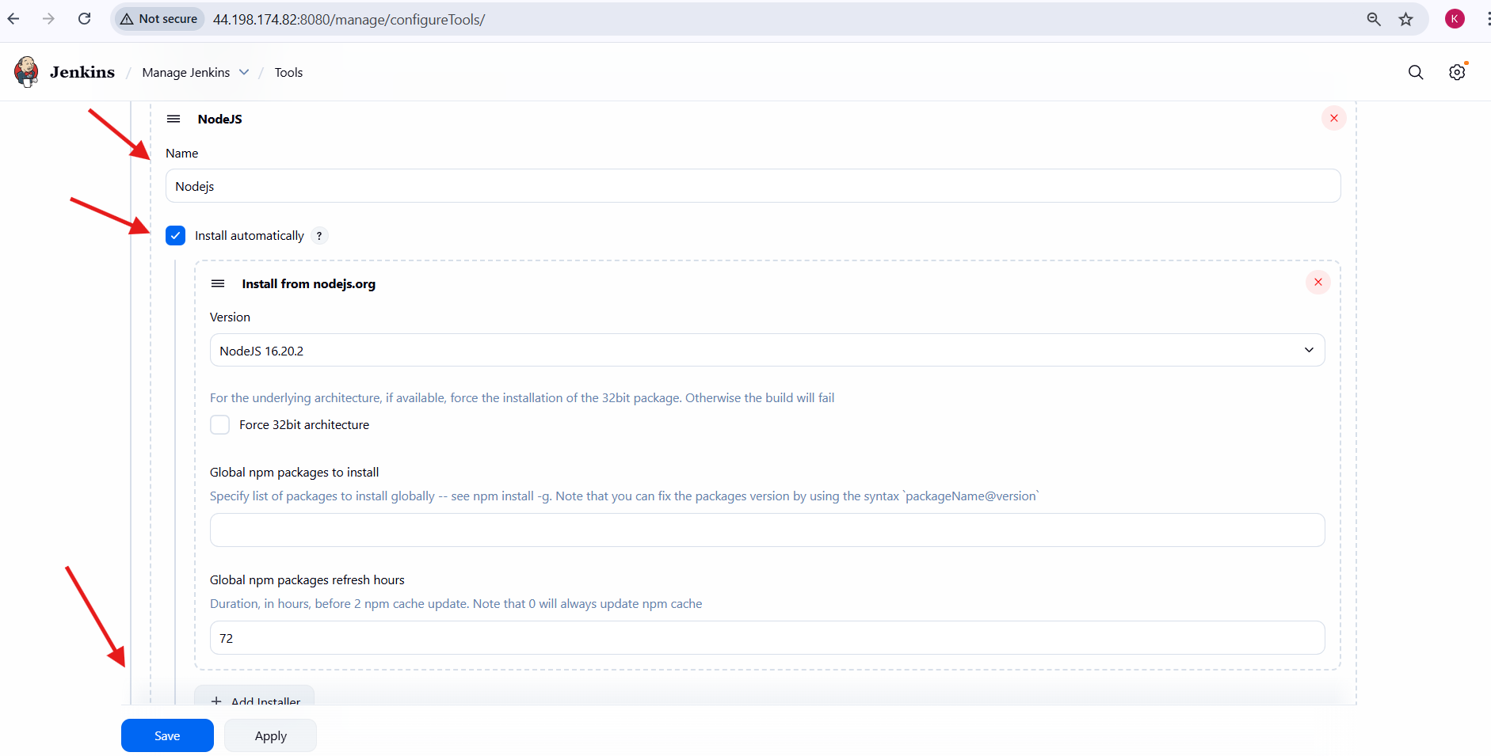
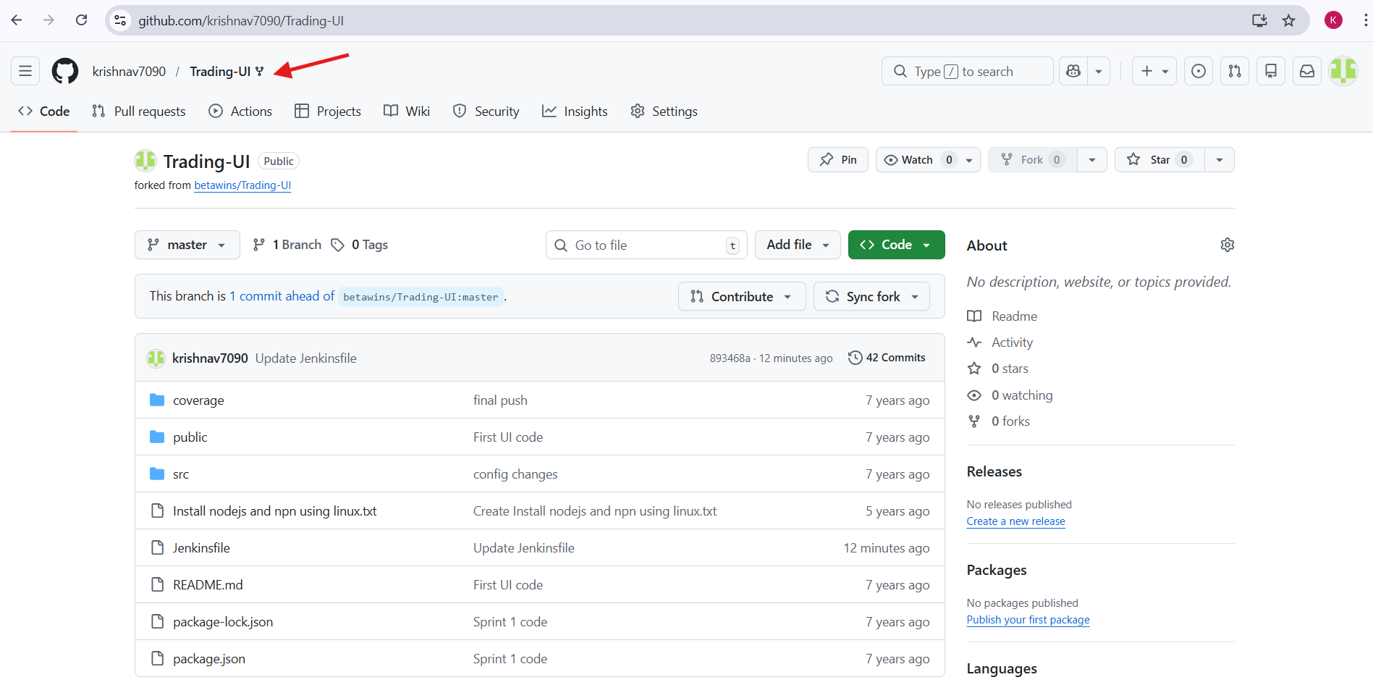
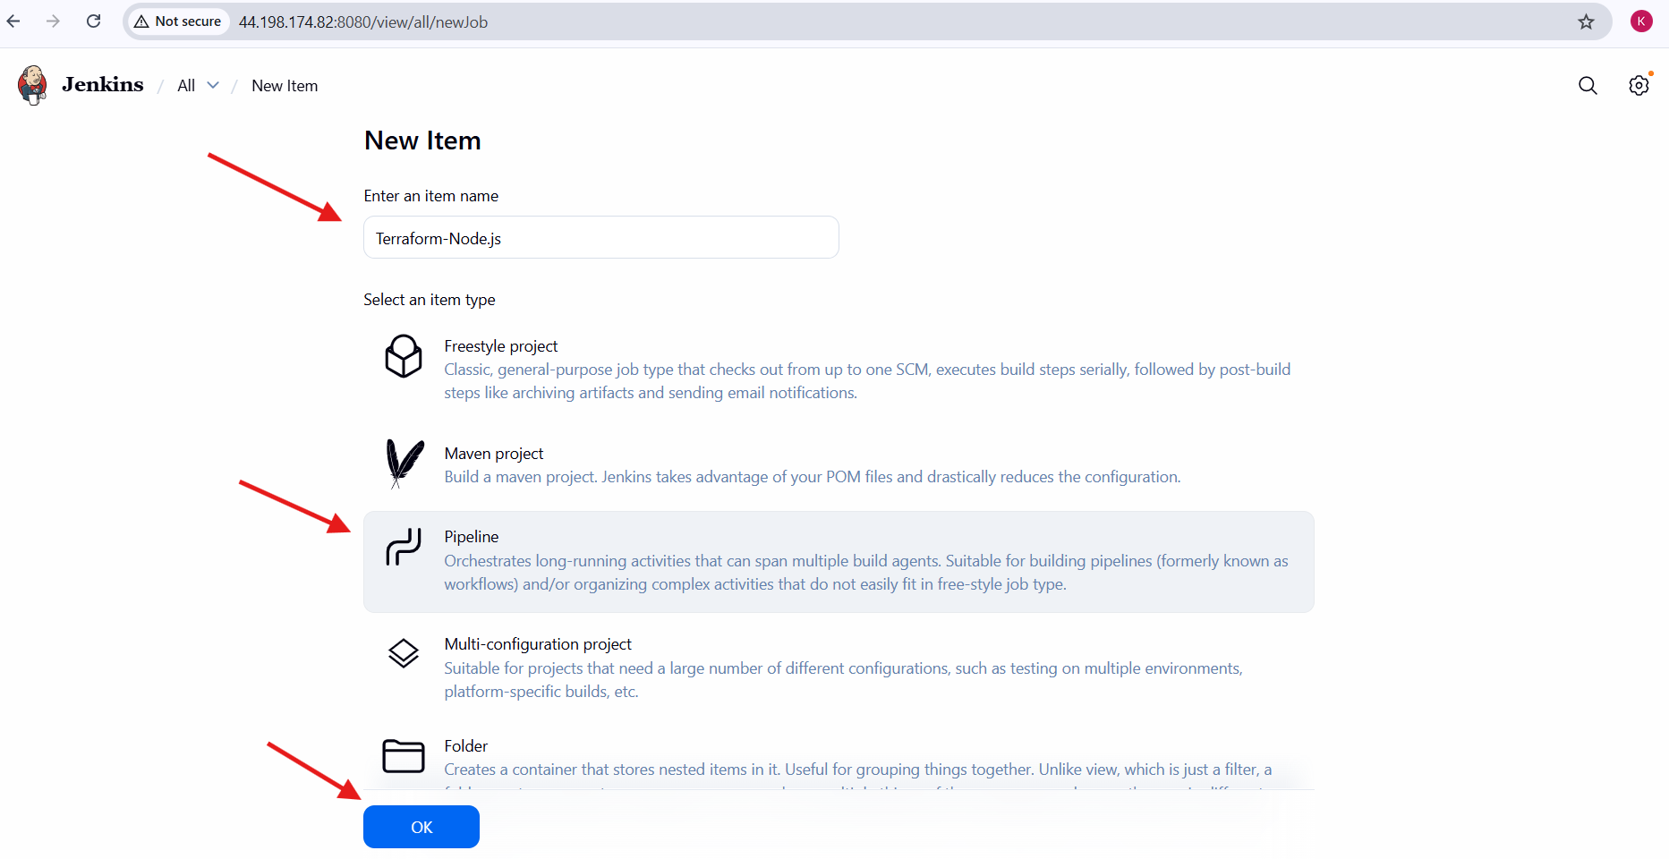
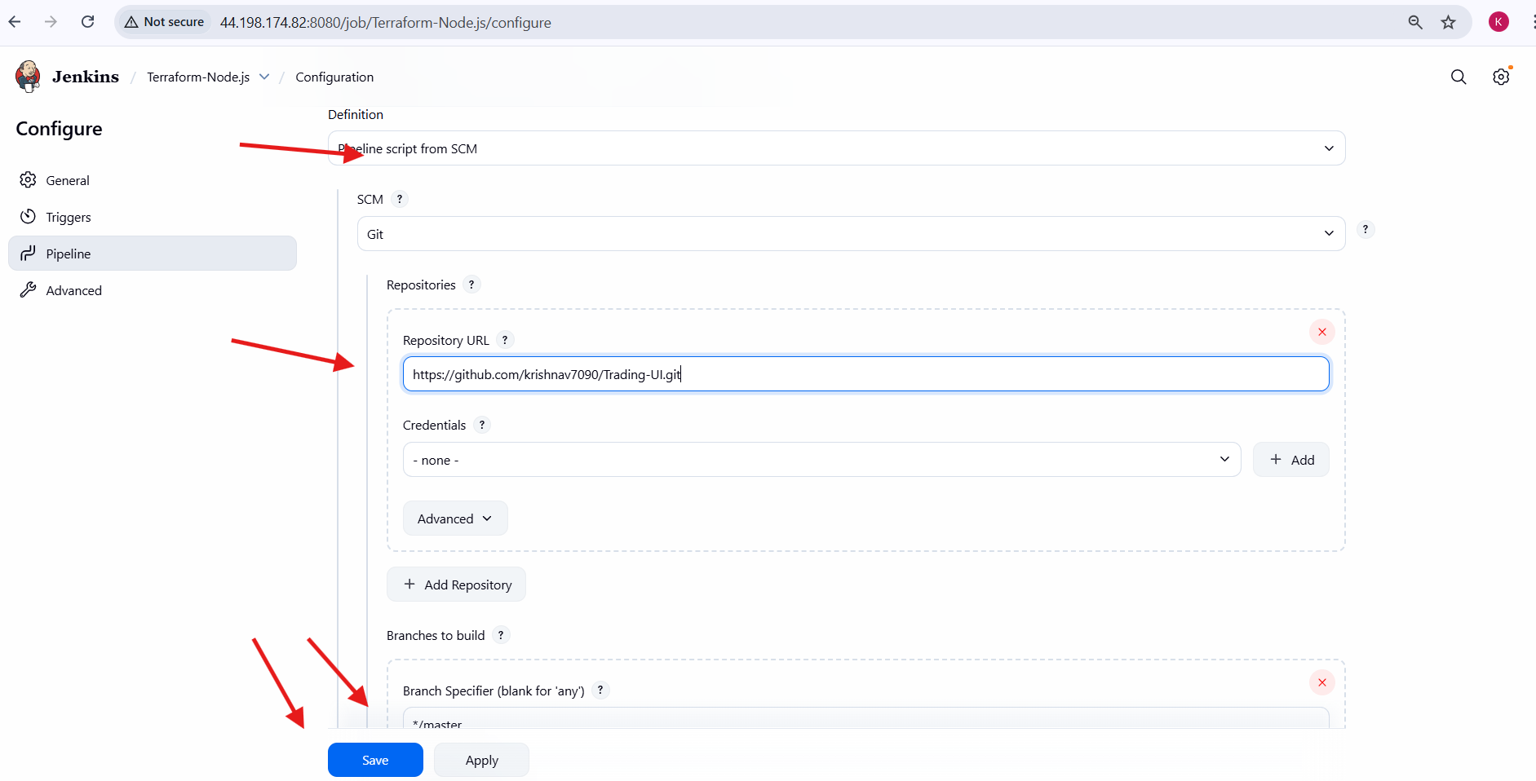
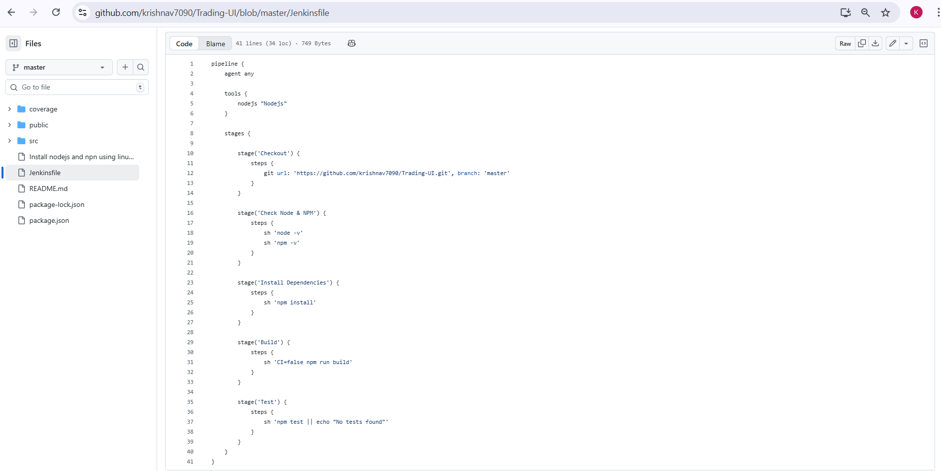
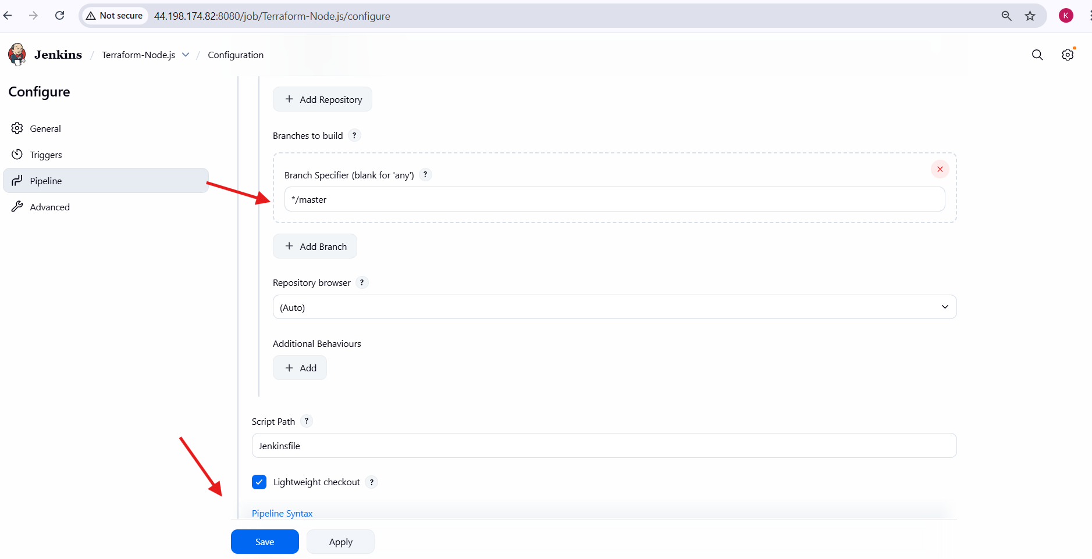
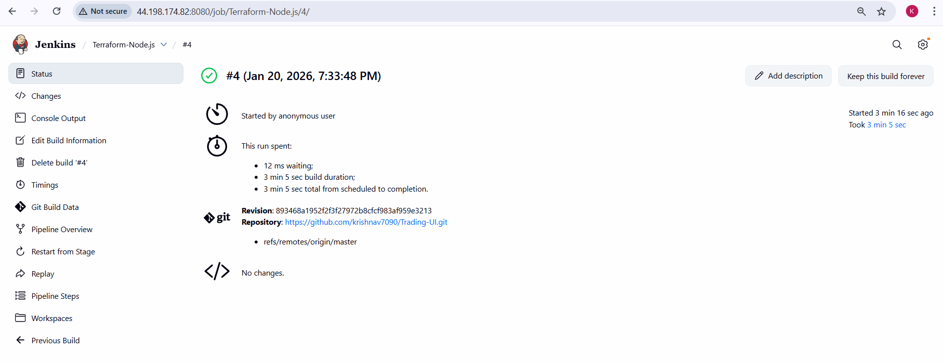
Conclusion
A CI/CD pipeline for a NodeJS application was successfully created using Jenkins. The pipeline automated the process of checking out source code from GitHub, installing dependencies, building the application, and executing tests. The pipeline executed successfully, demonstrating continuous integration for the NodeJS application and ensuring reliable and repeatable builds.

5. Explain 10 Maven commands.
1. mvn clean
Deletes the target directory generated by previous builds.
Purpose:
Ensures a fresh build by removing old compiled files.
2. mvn compile
Compiles the source code of the project.
Purpose:
Converts Java source files into bytecode and stores them in the target/classes directory.
3. mvn test
Runs unit tests using testing frameworks like JUnit or TestNG.
Purpose:
Verifies that the application code works as expected.
4. mvn package
Packages the compiled code into a distributable format such as JAR or WAR.
Purpose:
Creates the final build artifact inside the target directory.
5. mvn install
Builds the project and installs the artifact into the local Maven repository.
Purpose:
Makes the artifact available for other local projects as a dependency.
6. mvn deploy
Uploads the built artifact to a remote repository (like Nexus or Artifactory).
Purpose:
Shares the build with other developers or environments.
7. mvn validate
Validates the project structure and configuration.
Purpose:
Checks whether the project is correct and ready to build.
8. mvn clean install
Deletes old builds, compiles, tests, packages, and installs the project.
Purpose:
Performs a complete build cycle in one command.
9. mvn dependency:tree
Displays the project’s dependency hierarchy.
Purpose:
Helps identify dependency conflicts and understand transitive dependencies.
10. mvn help:effective-pom
Displays the final POM after inheritance and profiles are applied.
Purpose:
Helps debug and understand how Maven resolves configurations.

